HOSPITAL MANAGEMENT SYSTEM

STUDENT DETAILS
Field | Details
Student Name | CHURCHILL OMARI
Registration Number | ENE211/0044/2024
Institution | JOMO KENYATTA UNIVERSITY OG AGRICULTURE AND TECHNOLOGY
School/Department | DEPARTMENT OF ELECTRICAL ELECTRONICS
Course Unit | Object Oriented Programming
Submission Date | 19/5/2026
Project Title | Hospital Management System

TABLE OF CONTENTS
- Abstract
- Introduction
- Background Study
- Problem Statement
- Justification of the Project
- Main Objective
- Specific Objectives
- Scope of the Project
- Limitations of the Project
- Feasibility Study
- Literature Review
- System Analysis
- Functional Requirements
- Non-Functional Requirements
- Software Requirements
- Hardware Requirements
- System Design
- System Architecture
- Data Structures Used
- Object-Oriented Programming Concepts Used
- File Handling and Persistent Storage
- Modules Implemented
- Patient Management Module
- Doctor Management Module
- Appointment Management Module
- Queue Management Module
- Pharmacy Management Module
- Billing Management Module
- Room and Ward Management Module
- Authentication System
- Algorithms Used
- Program Flow
- Testing and Debugging
- Sample System Outputs
- Advantages of the System
- Challenges Encountered
- Future Improvements
- Conclusion
- References

1. ABSTRACT
The Hospital Management System is a comprehensive software application developed using the C++ programming language and Object-Oriented Programming (OOP) principles to automate and simplify hospital operations. The project was designed to simulate real-world hospital workflows and provide efficient management of patients, doctors, appointments, queues, pharmacy records, billing operations, and room allocations.
Modern hospitals handle large volumes of data every day. Managing these operations manually is inefficient, time-consuming, expensive, and highly prone to human error. This project addresses these challenges by providing a modular and scalable hospital management solution capable of maintaining patient records, scheduling appointments, generating bills, managing medicines, allocating hospital rooms, and maintaining persistent storage using file handling.
The system applies important computer science concepts such as vectors, queues, file handling, modular programming, encapsulation, inheritance, abstraction, and multi-file architecture. The system also supports persistent storage, ensuring that hospital records remain available even after restarting the program.
The project demonstrates how software engineering and Object-Oriented Programming concepts can be applied in solving real-world healthcare management problems.

2. INTRODUCTION
Healthcare institutions require efficient systems for managing patients, doctors, appointments, medicines, hospital rooms, billing information, and emergency services. Traditional manual systems involve paperwork and repetitive administrative tasks that lead to inefficiency, poor record management, and delays in service delivery.
The Hospital Management System was developed to provide an automated platform capable of handling major hospital operations in a centralized and organized manner. The system is designed using C++ and follows Object-Oriented Programming principles to ensure modularity, maintainability, scalability, and code reusability.
The application allows hospital administrators to:
- Register patients
- Register doctors
- Book and manage appointments
- Handle emergency and waiting queues
- Manage medicines in the pharmacy
- Generate patient bills
- Allocate hospital rooms
- Maintain records using persistent storage
The system simulates a real hospital environment and demonstrates how software systems improve operational efficiency in healthcare institutions.

3. BACKGROUND STUDY
Hospitals are among the most complex institutions because they manage a large number of patients, healthcare professionals, medications, records, appointments, and financial transactions every day.
Traditionally, hospitals relied heavily on manual record keeping using paper files. Such systems suffer from several disadvantages including:
- Difficulty retrieving patient records
- High risk of losing files
- Slow appointment scheduling
- Billing errors
- Poor queue management
- Difficulty tracking room occupancy
- Lack of centralized data management
With the advancement of information technology, computerized hospital management systems have become essential in improving efficiency, reducing errors, and enhancing patient care.
This project was developed to simulate a computerized hospital management environment using C++ programming.

4. PROBLEM STATEMENT
Many healthcare institutions still experience challenges associated with manual hospital management systems. These systems often result in:
- Poor patient record management
- Delayed appointment scheduling
- Inefficient queue handling
- Billing inconsistencies
- Poor medicine inventory tracking
- Difficulty monitoring hospital room occupancy
- Loss of records
- Increased operational costs
- Slow administrative processes
There is therefore a need for a computerized system capable of automating hospital operations and improving efficiency.

5. JUSTIFICATION OF THE PROJECT
The development of the Hospital Management System is important because it:
- Improves hospital efficiency
- Reduces paperwork
- Minimizes human errors
- Speeds up patient services
- Enhances data organization
- Simplifies billing operations
- Improves queue management
- Helps manage medicine inventory
- Supports hospital room allocation
- Demonstrates practical application of OOP concepts

6. MAIN OBJECTIVE
To develop a comprehensive Hospital Management System capable of automating major hospital operations using Object-Oriented Programming concepts in C++.

7. SPECIFIC OBJECTIVES
The project aims to:
- Register and manage patient records
- Register and manage doctors
- Schedule and manage appointments
- Implement queue management systems
- Handle emergency patient queues
- Manage medicine inventory
- Generate hospital bills
- Allocate and manage hospital rooms
- Store records persistently using files
- Apply Object-Oriented Programming concepts
- Demonstrate use of data structures in real-world systems

8. SCOPE OF THE PROJECT
The Hospital Management System focuses on the following areas:

Included Features
- Login system
- Patient management
- Doctor management
- Appointment management
- Waiting queue management
- Emergency queue management
- Pharmacy management
- Billing management
- Room and ward management
- Persistent file storage
- Menu-driven interaction

Excluded Features
- Real database connectivity
- Web integration
- Mobile application support
- Real-time networking
- Cloud synchronization
- Biometric authentication
- Real medical equipment integration

9. LIMITATIONS OF THE PROJECT
Although the system performs many hospital operations, it has some limitations:
- Uses text files instead of databases
- No graphical user interface (GUI)
- No real-time online synchronization
- No multi-user concurrency
- No real payment gateway integration
- No real hospital hardware integration

10. FEASIBILITY STUDY

Technical Feasibility
The system is technically feasible because it was developed using standard C++ programming techniques and can run on ordinary computers.

Economic Feasibility
The project is cost-effective because it uses open-source tools and requires minimal hardware resources.

Operational Feasibility
The system is user-friendly and suitable for simulation of hospital workflows.

11. LITERATURE REVIEW
Hospital Management Systems have become essential in healthcare institutions worldwide. Many modern hospitals use software solutions to automate operations such as patient registration, billing, appointment scheduling, pharmacy management, and room allocation.
Object-Oriented Programming provides a suitable approach for building such systems because it promotes:
- Reusability
- Maintainability
- Scalability
- Modularity
Data structures such as vectors and queues are also commonly used in management systems for organizing dynamic data efficiently.
This project combines OOP principles with data structures and file handling to simulate a real hospital ERP environment.

12. SYSTEM ANALYSIS
The Hospital Management System was analyzed based on major hospital workflows.

Inputs
- Patient details
- Doctor details
- Appointment details
- Medicine information
- Billing information
- Room allocation details

Processes
- Registration
- Appointment booking
- Queue handling
- Bill generation
- Room allocation
- File saving and loading

Outputs
- Patient records
- Doctor records
- Appointment schedules
- Medicine inventory lists
- Bills and invoices
- Room occupancy reports

13. FUNCTIONAL REQUIREMENTS
The system shall be able to:
- Allow administrator login
- Add new patients
- Display patient records
- Search patients
- Add doctors
- Display doctors
- Book appointments
- Display appointments
- Cancel appointments
- Manage waiting queues
- Handle emergency queues
- Add medicines
- Display medicines
- Update medicine stock
- Generate patient bills
- Display bills
- Add hospital rooms
- Display rooms
- Admit patients into rooms
- Discharge rooms
- Save records persistently
- Load records automatically after restart

14. NON-FUNCTIONAL REQUIREMENTS
The system should:
- Be user friendly
- Respond quickly
- Be reliable
- Be scalable
- Be easy to maintain
- Provide accurate outputs
- Support modular development
- Support persistent storage

15. SOFTWARE REQUIREMENTS
The project requires:
- C++ Compiler
- Code::Blocks / Visual Studio / Dev-C++
- Windows or Linux Operating System

16. HARDWARE REQUIREMENTS
The project can run on:
- Intel or AMD Processor
- 4GB RAM or higher
- Standard keyboard and monitor
- Storage device

17. SYSTEM DESIGN
The system follows a modular architecture where each component performs specific responsibilities.
Main modules include:
- Authentication Module
- Patient Module
- Doctor Module
- Appointment Module
- Queue Module
- Pharmacy Module
- Billing Module
- Room Module
- Persistent Storage Module
Each module interacts with the main HospitalSystem controller.

18. SYSTEM ARCHITECTURE
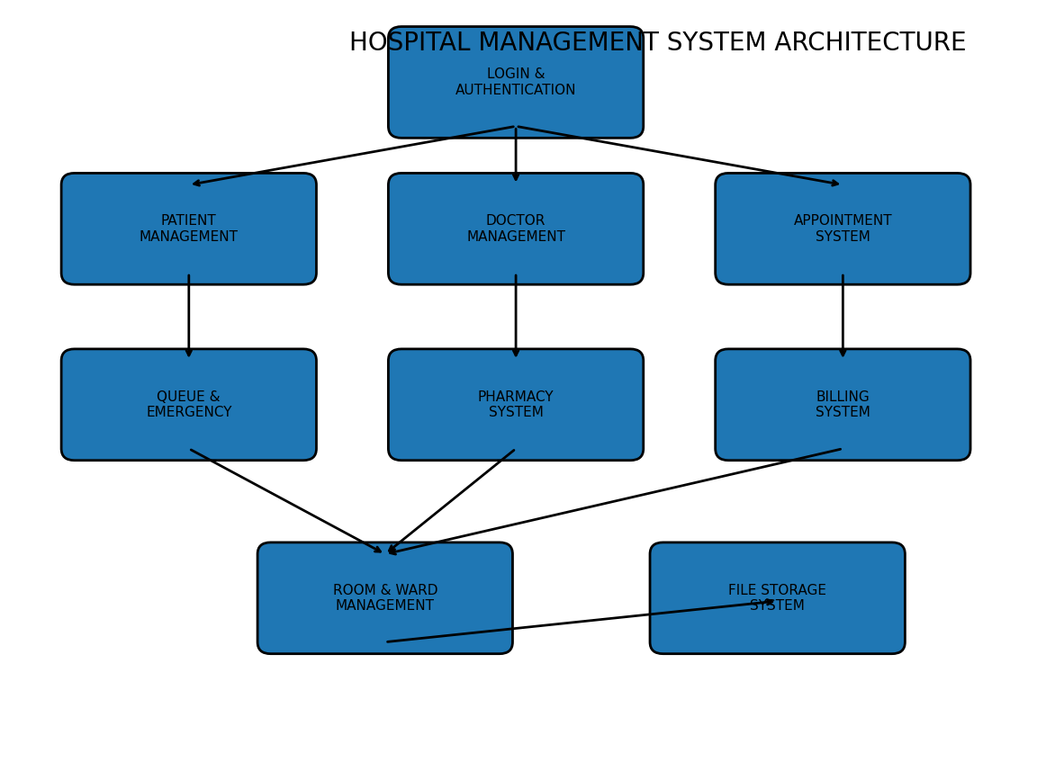

Main Components

1. User Interface Module
Handles all user interactions through terminal menus.

2. Patient Management Module
Stores and manages patient records.

3. Doctor Management Module
Stores doctor details and specialties.

4. Appointment Management Module
Schedules and manages appointments.

5. Queue Management Module
Handles patient waiting queues using FIFO logic.

6. Pharmacy Module
Manages medicine inventory.

7. Billing Module
Generates and stores patient bills.

8. Room Management Module
Handles hospital room allocation.

9. File Handling Module
Maintains persistent storage.

19. DATA STRUCTURES USED

19.1 Vectors
Vectors were used for:
- Patient storage
- Doctor storage
- Appointments
- Medicines
- Bills
- Rooms
Reason: Vectors support dynamic memory allocation and efficient record management.

19.2 Queue
Queue was used for patient waiting management.
Reason: Patients are served using First-In-First-Out (FIFO).

19.3 File Streams
File streams were used for:
- Saving records
- Loading records
- Maintaining persistent storage

20. OBJECT-ORIENTED PROGRAMMING CONCEPTS USED

20.1 Classes and Objects
Classes implemented include:
- Person
- Patient
- Doctor
- Appointment
- Medicine
- Bill
- Room
- HospitalSystem
Objects are created from these classes.

20.2 Encapsulation
Private data members were used to protect sensitive data.
Examples:
- Patient information
- Medicine stock
- Billing details

20.3 Inheritance
The Patient and Doctor classes inherit from the Person base class.

20.4 Abstraction
Complex operations are hidden inside functions.
Examples:
- savePatients()
- loadPatients()
- generateBill()
- bookAppointment()

20.5 Modularity
The project uses separate header and implementation files.

21. FILE HANDLING AND PERSISTENT STORAGE
Persistent storage was implemented using text files.
Files include:
- patients.txt
- doctors.txt
- appointments.txt
- medicines.txt
- bills.txt
- rooms.txt
Purpose:
- Preserve records after restarting the program
- Simulate database functionality

22. MODULES IMPLEMENTED
The project currently contains the following completed modules:
Module | Status
Authentication System | Completed
Patient Management | Completed
Doctor Management | Completed
Appointment Management | Completed
Queue Management | Completed
Emergency Queue | Completed
Pharmacy Management | Completed
Billing Management | Completed
Room and Ward Management | Completed
Persistent Storage | Completed

23. PATIENT MANAGEMENT MODULE
This module handles:
- Adding patients
- Displaying patient records
- Searching patients
- Discharging patients
Features:
- Unique patient IDs
- Disease tracking
- Admission status

24. DOCTOR MANAGEMENT MODULE
This module handles:
- Adding doctors
- Displaying doctor records
- Assigning doctors to patients
Features:
- Doctor specialties
- Doctor identification system

25. APPOINTMENT MANAGEMENT MODULE
This module handles:
- Appointment booking
- Appointment cancellation
- Appointment display
Features:
- Duplicate appointment validation
- Persistent appointment storage
- Appointment scheduling

26. QUEUE MANAGEMENT MODULE
The queue system manages patient waiting lines.
Features:
- FIFO queue handling
- Emergency queue support
- Patient serving logic
Importance:
Ensures fair patient servicing order.

27. PHARMACY MANAGEMENT MODULE
This module manages hospital medicines.
Features:
- Add medicines
- Display medicines
- Track medicine stock
- Medicine persistence

28. BILLING MANAGEMENT MODULE
This module handles patient bills.
Features:
- Generate bills
- Display bills
- Store payment information
- Persistent bill storage
Billing includes:
- Doctor fee
- Medicine charges
- Room charges

29. ROOM AND WARD MANAGEMENT MODULE
This module handles:
- Room creation
- Patient admission
- Room occupancy
- Room discharge
Room types include:
- ICU
- VIP
- General Ward

30. AUTHENTICATION SYSTEM
The login system provides administrator authentication.
Features:
- Username validation
- Password validation
- Access control

31. ALGORITHMS USED
Algorithms implemented include:
- Searching algorithms
- Queue processing algorithms
- Record validation algorithms
- Duplicate ID checking
- Room occupancy checking

32. PROGRAM FLOW
- User logs into system.
- Main menu is displayed.
- User selects operation.
- System processes data.
- Data is saved persistently.
- Results are displayed.

33. TESTING AND DEBUGGING
The project was tested incrementally.

Tests Performed
- Login validation
- Patient addition
- Doctor registration
- Appointment booking
- Queue processing
- Medicine display
- Bill generation
- Room allocation
- Persistent storage verification

Debugging Strategy
Debug messages were used to:
- Verify vector sizes
- Validate menu cases
- Confirm file loading
- Detect missing records

34. SAMPLE SYSTEM OUTPUTS

Login Screen
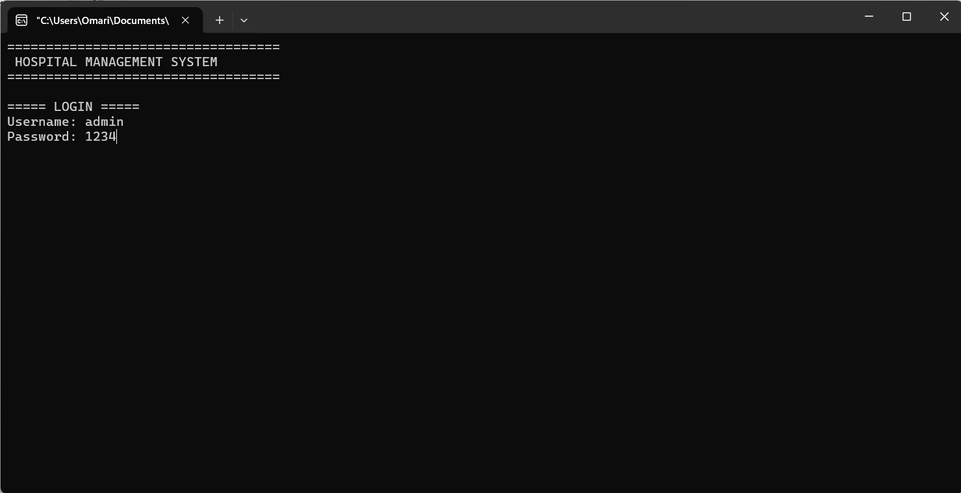

Main Menu
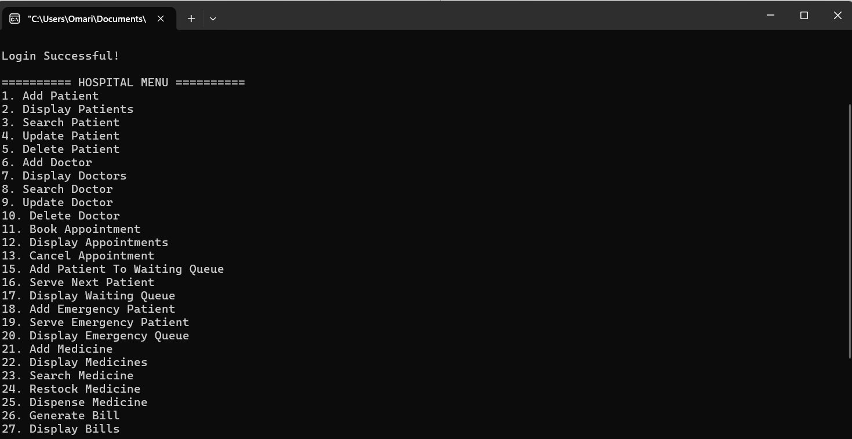
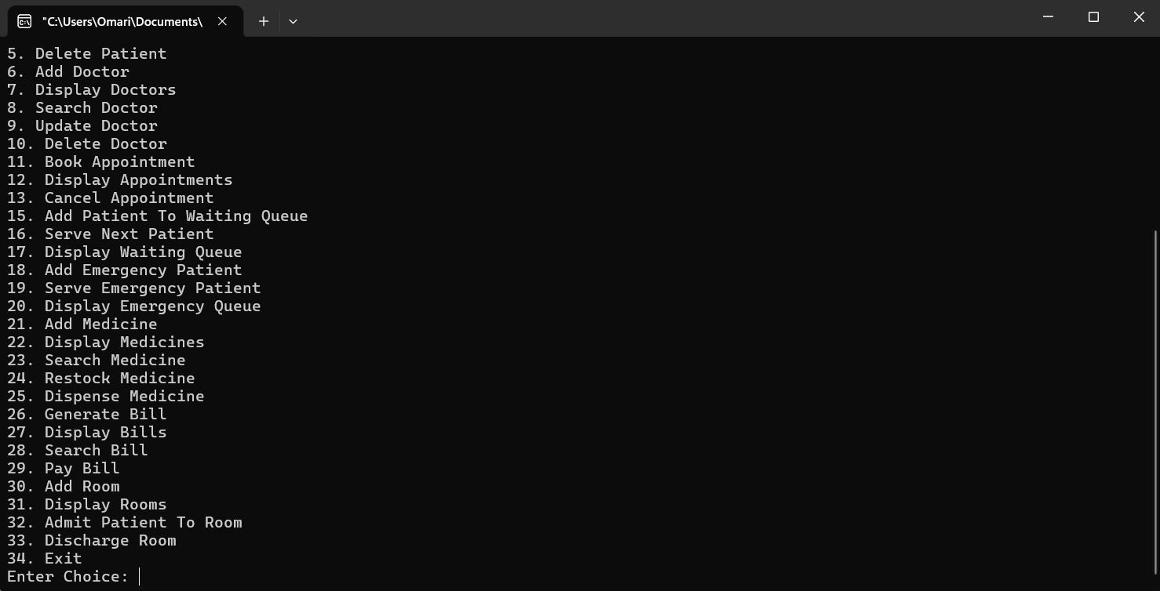
.Adding patient
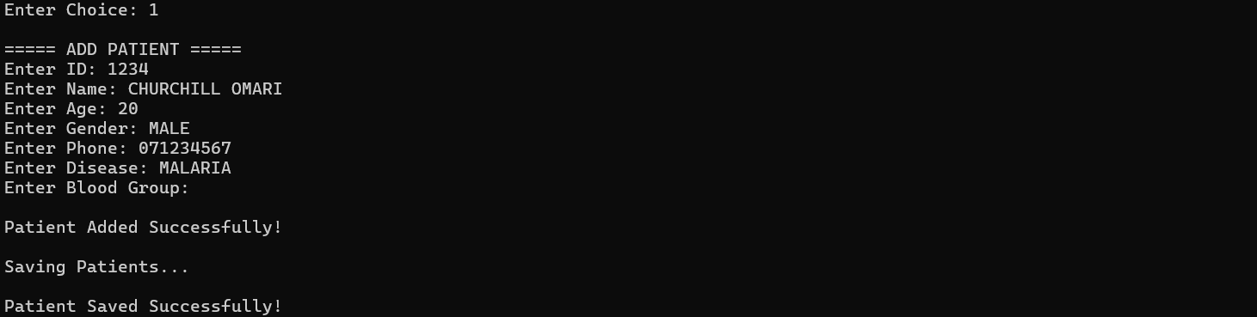
.Displaying patient admitted
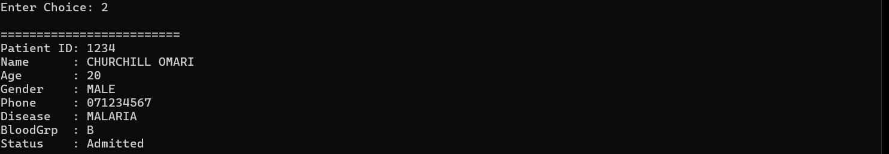
.Search Patient
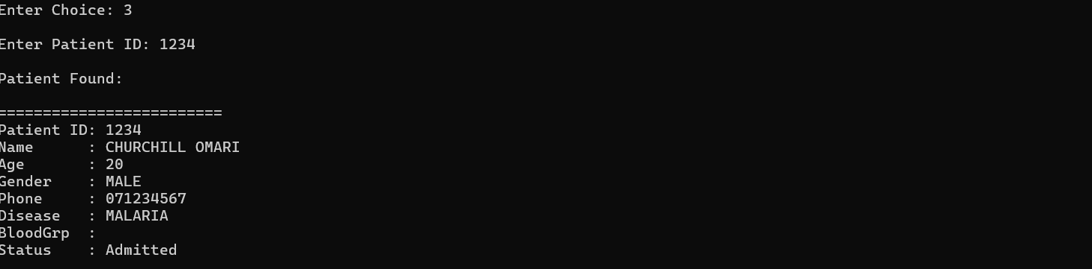
.Updating patient
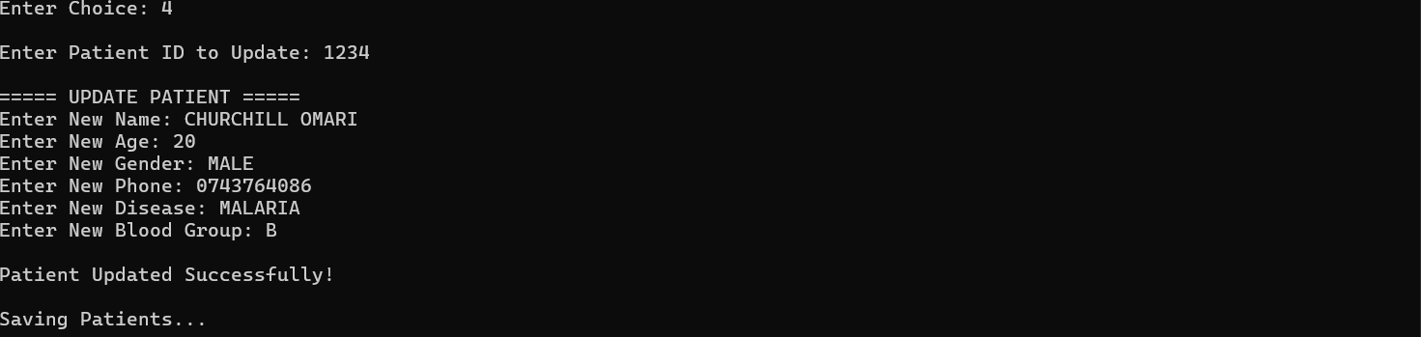
.Deleting patient from system
.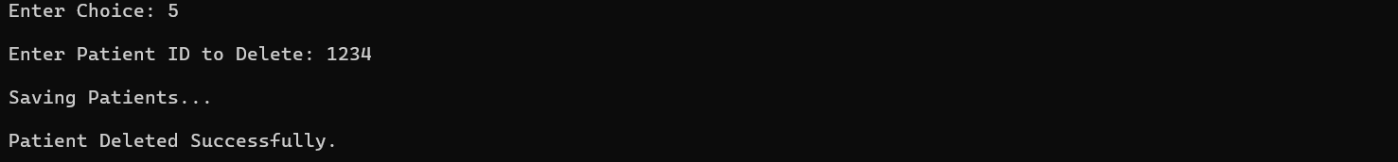

.Add doctor
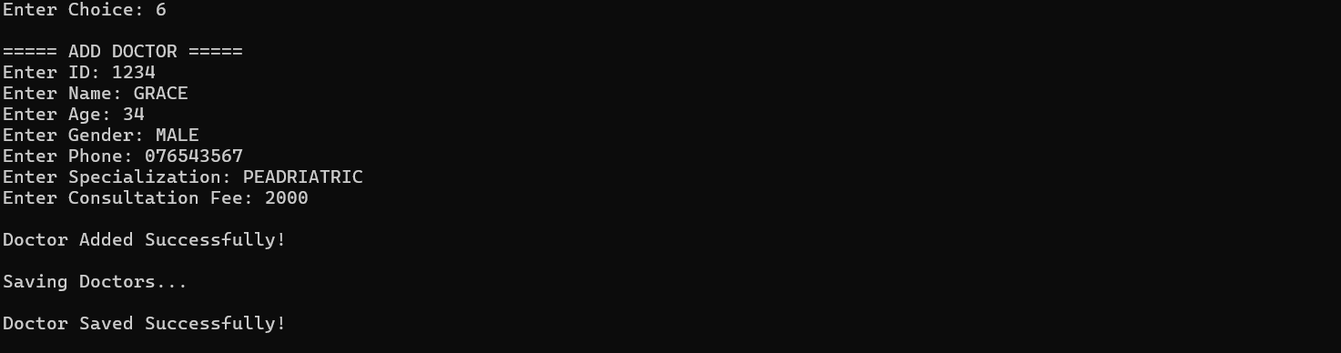

.Display Doctor
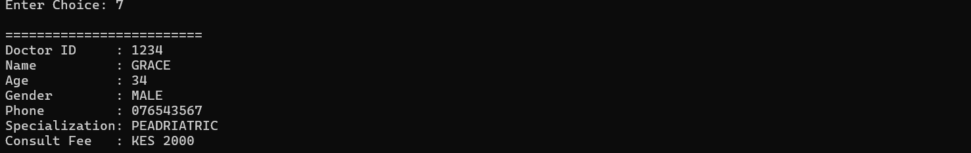

.Search Doctor
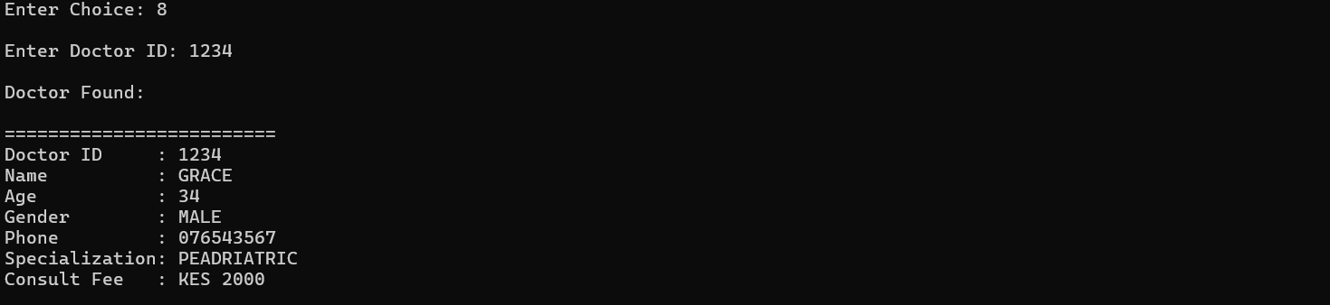
.Update doctor
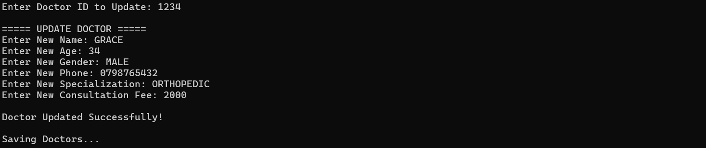
.Delete doctor
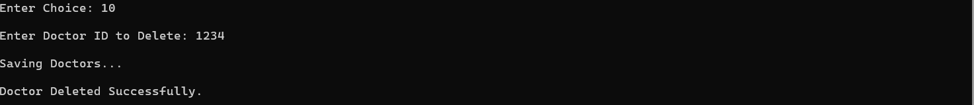

NOTE… DUE TO MANY FUNCTIONS IN THE SYSTEM I HAVE DISPLAYED 10 FUNCTIONALITIES…..ALL FUNCTIONALITY ADD UP TO 33

35. ADVANTAGES OF THE SYSTEM
- Improves hospital efficiency
- Reduces paperwork
- Organizes records properly
- Supports persistent storage
- Simplifies billing
- Improves queue handling
- Modular and scalable
- Easy to maintain

36. CHALLENGES ENCOUNTERED
Challenges faced during development include:
- File synchronization issues
- Debugging menu systems
- Managing persistent storage
- Preventing duplicate records
- Integrating multiple modules
- Maintaining clean modular architecture

37. FUTURE IMPROVEMENTS
Future enhancements may include:
- Graphical User Interface (GUI)
- SQL database integration
- Online appointment booking
- Networking support
- Laboratory management system
- Ambulance management system
- Payroll system
- AI-based hospital analytics
- Cloud synchronization
- Mobile application support

38. CONCLUSION
The Hospital Management System successfully demonstrates the practical application of Object-Oriented Programming and data structures in solving real-world healthcare management problems.
The project automates major hospital workflows including patient management, doctor management, appointment scheduling, queue handling, medicine inventory, billing, room allocation, and persistent data storage.
The project also demonstrates important software engineering concepts such as modularity, scalability, maintainability, file handling, abstraction, inheritance, encapsulation, and data structures.
The system provides a strong foundation for future expansion into a complete enterprise hospital ERP solution.

39. REFERENCES
- Object-Oriented Programming with C++
- Data Structures and Algorithms in C++
- Hospital Information Systems Research Papers
- C++ Standard Library Documentation
- Healthcare Management Systems Documentation

